Prabhat Singh – Task 3
Ans 1-
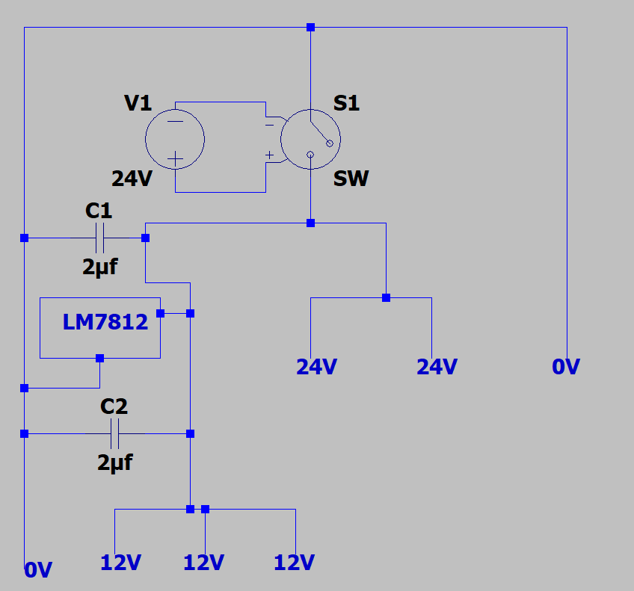
Ans 2-:
Antennas are basically devices which convert electrical energy into electromagnetic waves or electromagnetic fields. In short they act as a transducers. They can act as a receiver and also as a transmitter.
Radiation Mechanism-:
A conductor which is designed to carry current for long distances and with minimal losses is known as Transmission Line. Now when a time varying polarity voltage that is AC voltage is applied across the two conductor transmission lines electric field is generated between them also movement of charges produces current thus magnetic field intensity is generated around conductor. Now Magnetic field lines forms the closed loops around the current carrying conductor. Now if we assume that the AC voltage is a sinusoidal wave and with time period of T then the Electric field generated is also sinusoidal and with same wavelength.
The Following image shows the generation of electric field in the transmission line when the AC voltage is applied across it also shows how reversing the polarity generates opposite direction electric fields.
Thus creation of time varying electric and magnetic field generates electromagnetic waves. Also the second part of the image shows how electric fields can be detached from the conductor since these electric fields are Induced Electric Fields thus they can form closed loops as well.
Also we can conclude one more thing from the above result that electric charges are needed for the generation of electric fields but they are not needed to sustain them and they may exist in their absence just like in Vacuum.

Different types of Antenna-:
- Dipole Antenna-:
Dipole antenna are the antennas containing two conductive items through which the energy conversion takes place that is from electrical energy to electromagnectic energy. Also these antennas are one of the most commonly used antennas.
The above diagram shows the radiation mechanism in the dipole antenna in this antennas the current flows through the conductive region and thus elecltric field is generated also magnetic field is generated across the conductor thus we obtain the EM wave whose time period is same as that of the source applied used across the conductor.

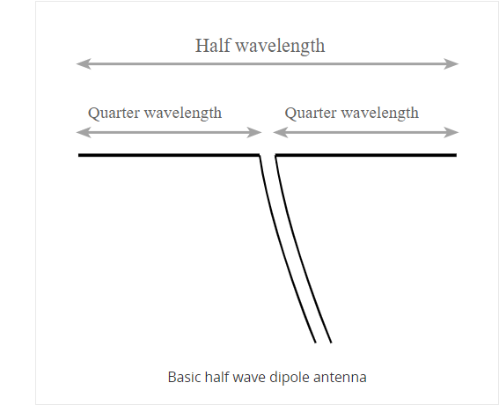
THE ADVANTAGES OF DIPOLE ANTENNAS-:
The Dipole antenna is extremely simple as compared to most of the other antennas, dipole antennas are most efficient when used at their resonant frequency. Dipole antennas are omnidirectional that is they receive and transmit signals in all signals thus they can receive signals easily if it’s frequency falls in the range of that antenna.
THE DISADVANTAGES OF DIPOLE ANTENNAS-:
Dipole antennas are good choice for high frequency and low wavelength type of signals but not for the low frequency signals. Also the efficiency decreases at the low frequencies since the length of the antenna decreases

- OMNI DIRECTIONAL ANTENNA-:
These are the antennas which radiates in all directional with equal power but perpendicular to their axis of rotation and their axis is vertical thus they radiate with maximum intensity in horizontal direction and as we move up and down the axis intensity is reduced gradually thus reducing the amount of wastage by radiating in the Earth or sky. These kind of antennas are widely used in radio broadcasting , FM radios and walkie-talkies. These antennas can be low gain and high gain. Higher Gain Antennas basically means they radiate very low power signals at the tip and at the bottom of the axis. These antennas basically contains multiple half wave dipoles.
ADVANTAGES AND DISADVANTAGES OF THE OMNI ANTENNA -:
The biggest advantage of these types of antennas are that they can receive signals from any direction but this thing also serves as there disadvantages because they receive many interference due to other waves also the overall gain of the omni directional antennas are relatively lower.

PATCH ANTENNAS-:
Patch antennas or microstrip antennas are the antennas with very small size. In these antennas basically a square shaped or any continuous metal strip is cut and is installed on top of the dielectric material and after this the dielectric material is again covered with a metal piece which acts as a ground material. They can be fed with various techniques.
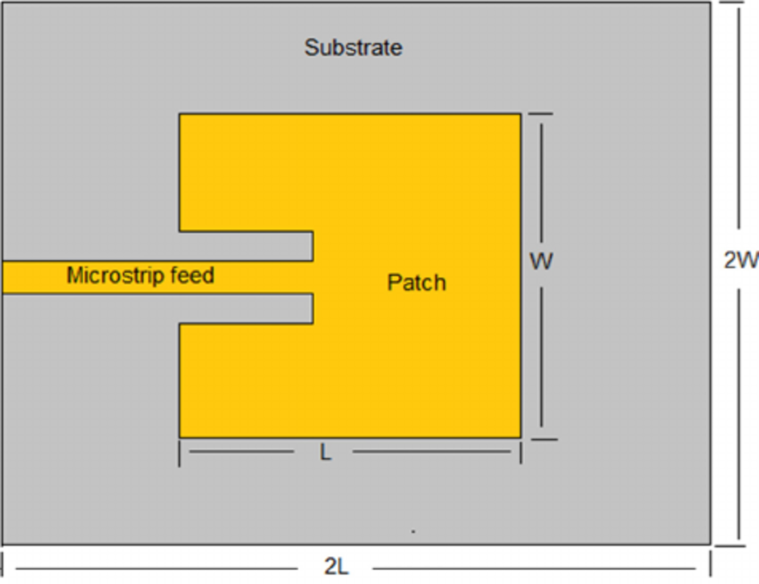
The above diagram basically shows the basic design of the patch antennas.
Various Feeding Methods of the patch antennas-
1.Microstrip Feed.
2. Coaxial Feed.
3.Coupled Feed.
Below is the diagram of the radiation pattern of the patch antenna.
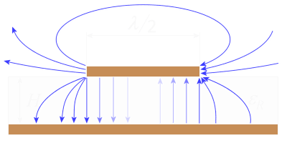
These antennas have narrow bandwidth and also they are lesser directive. They are less efficient.
Ans 4.
What is a Microprocessor?
Microprocessor is an integrated circuit(IC) or a controlling unit of a micro-computer. It basically consists of various units like Arithmetic and Logical Unit, Control Unit and Register Array. ALU or Arithmetic and Logical Unit performs all the arithmetic and logical operations on the data received from input devices or through memory. Register arrays consists of various ALPHABETICALLY labelled register like accumulators and they act as temporary fast access memory locations for processing data. And Control unit is basically the unit controlling the flow of instructions and data throughout the system. So Microprocessor is a small chip which incorporates most of the task of a CPU.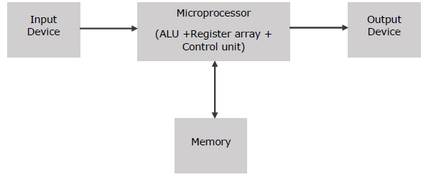
Microprocessor works on some set of commands and based on those commands it performs various tasks given to it.
Some common terms that are used in microprocessor are-:
- BUS- A bus is group of wires which are meant to transfer data in binary form of the given set of commands or inputs. They can be unidirectional or bidirectional depending on the usage. Now buses can be internal buses and external buses. Internal buses are the ones which connects all the internal components of a computer. They are also referred as a Local Buses because they are basically made to connect the internal parts. External Buses these buses connects the microprocessor with different external components of the computer.

- Instruction Set-:
Instruction set are the set of commands that are given by the user to the microprocessor which microprocessor understands after decoding it. These commands basically orders or ask the microprocessor to perform various task whether it is to transfer data or switching on and off various transistors for doing a particular task.
- Word Length-:
Word Length of a processor is the maximum number of bits a processor can process at a time. Hence an 8 bit processor can process 8 bits at a time and has equivalent data bus wires or conductor or connectivity too.
- Clock Speed-:
It determines the number of operations per second the processor can perform. It is in megahertz(MHz) or gigahertz(GHz).
What is a Microcontroller ?
A microcontroller is a small device which on which various components are embedded or installed on it like a microprocessor, I/O pins, ROM and other necessary things, basically micro-controller is almost like a small computer which can do only few task by consuming less power and less space. They are also known as a special purpose computers. They are given set of commands or a program through a software with which they are compatible and thus they execute the task. Now microcontrollers can come with many advance features as well like preinstalled WiFi module or Bluetooth module or whatever the user desires they can be made into taht .
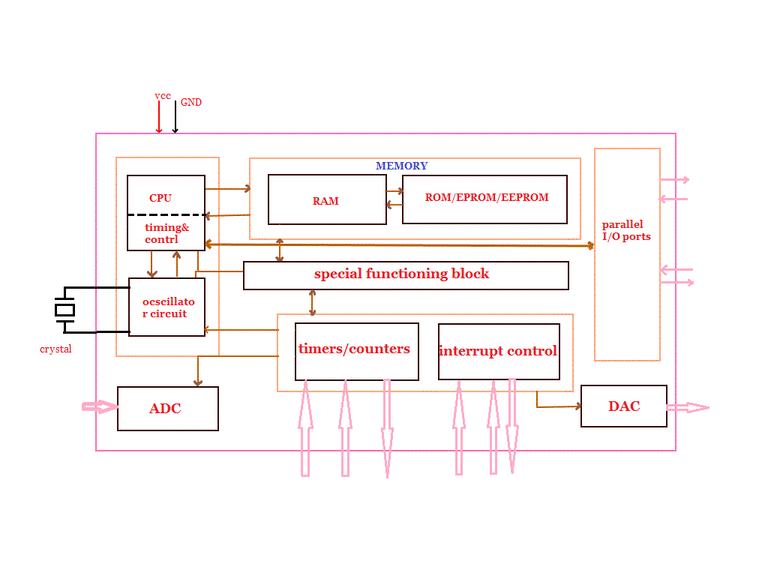
Parts of Microcontroller-:
- Timer/Counters-:
These are the devices that perform most of the clock related functions for the microcontrollers like The major operations of this section are performed clock functions, modulations, pulse generations, frequency measuring, making oscillations and various other task.
- Analog to Digital Convertor-:
This basically converts the analog input signals to digital form.
- Digital to Analog Convertor-:
This device basically does the reverse of ADC thus it is usually used to control analog devices such as motors which requires analog input and when our program contains digital signals.
Example of Microcontrollers are-: Atmega 328p,Atmega168.
NOTE-: Arduino is development board it’s neither a microcontroller nor a microprocessor also R-Pi is a single board computer.

METHANE AND PH SENSOR
Methane is one of the most important element of the natural gas which is highly inflammable gas. Thus it is important to keep the track of this gas, also since this gas is odourless so it’s hard to track them through sense smell. Thus to track this gas we can use a sensor known as MQ-4 these sensors basically use a heater and an electro-chemical sensor to detect various combinations of gases present in the nature. The sensitive material that is used in this sensor is SnO2 which is with lower conductivity in clean air but as soon as the target is combustible as in case of methane the conductivity of the sensor increases accordingly. It can detect propane and butane as well but it is highly sensitive to methane. The sensor operates on a stable 5V.

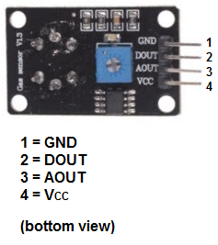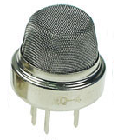
Basically the sensor contains 4 pins
1-GND should be grounded
2. DOUT- it means digital output
3-AOUT- it means analog output.
4.Vcc which should be connected to 5V source.

Arduino Code-:
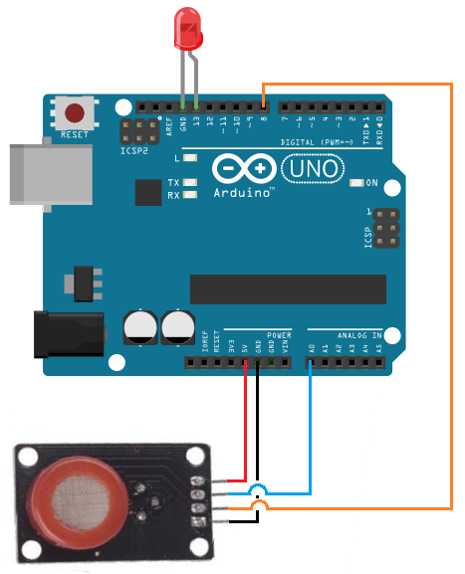
Anainp =A0;
Dinp=8;
LED=13;
flaot val;
int Dval;
void setup ()
{
Serial.begin(9600);
pinMode (Dinp, INPUT);
pinMode (Anainp, INPUT);
pinMode (LED,OUTPUT);
}
void loop()
{
val=analogRead(Anainp);
Dinp=digitalRead(Dinp);
Serial.println(“Methane value in analog is : ”);
Serial.println(val);
Serial.println(“ ” );
Serial.println(“Methane value or presesnce in digital value is : ”);
Serial.println(Dinp);
}

PH SENSOR-:
PH sensor is a sensor is a sensor that is used to get the hydrogen concentration of the bodies or the materials in which we are interested. Basically ph sensor uses the concept of electrochemical cell to get the concentration of hydrogen. That is it measures the potential difference across the cell and thus finds out the concentration of hydrogen and from the concentration of hydrogen it gets the PH of the particular body. These sensors requires the calibration of the PH value thus we need to adjust the value of resistors on top of the sensor to make sure sensor is giving us the exact true of the known solution.
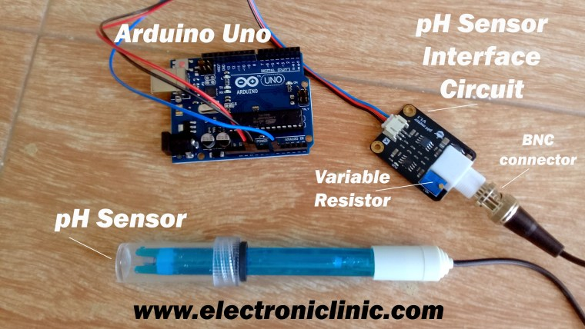
This sensor contains three pins that is Vcc, GND and a pin to give analog input to the Arduino.
Arduino Code-:
Inp=A0;
float val;
Void setup()
{
Serial.begin(9600);
pinMode(Inp,INPUT);
}
void loop()
{
Val=analogRead(Inp);
Serial.println(“ PH VALUE : ”);
Serial.println(val);
}

I2C BUS OR I2C COMMUNICATION
I2C is basically a communication between various devices which contains masters and slaves there can be multiple masters and multiple slaves. It is Half Duplex that is at a time only one can send or receive data also it uses only two pins to communicate that is SDA and SCL that is serial data and serial clock. Also it requires two pull up resistors one for each line.
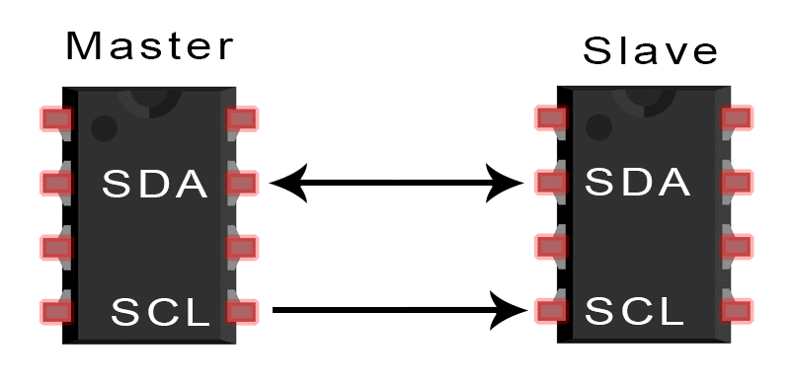
Also this communication has three different speed modes that is of 100Kbs ,400Kbps and 5 Mbps. Communication and complexity involved in this bus is relatively greater as compared to other communication modes. Also this bus provides 8 bits unique address to each and every device which is connected for communication this is to make sure there is no confusion during the data transfer between master and the slave.

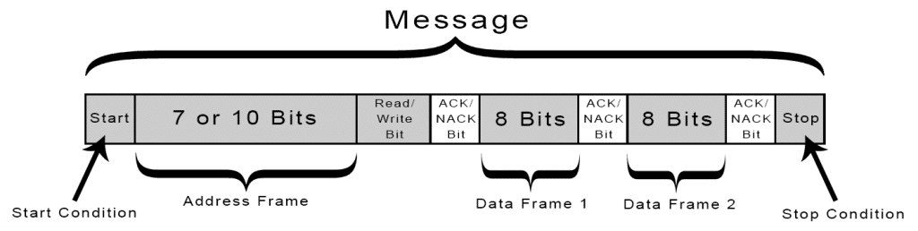
Now since both SDA and SCL are connected to a pull up resistors thus they are by default high. To START the data communication the SDA is pulled to LOW while the SCL is still HIGH and to STOP the communication SDA is pulled HIGH while the SCL is still HIGH. These are the only TWO special conditions where SDA can toggle between high and low even when the clock is High rest all the time SDA can toggle only when the SCL is LOW . Address Frame is basically sending address to the line to communicate with the particular slave of that address READ/WRITE block is the block which tells the that whether the master wants to read the data from it or write the data on it. If the SDA is HIGH then the master wants to read the data if the SDA is LOW then it means that master wants to write the data on it. ACK/NACK is basically the acknowledgement block which basically confirms the devices in communication that I got your command when it is 1 or HIGH it means that it is NOT ACKNOWLEDGED and when it is LOW then it means that it is acknowledged. And after all this the data is finally transferred to the or received between them.

SPI COMMUNICATION
Serial Peripheral Interface or SPI is the mode of communication which is faster than I2C and uses more wires than I2C also it uses 4 pins minimum can be more on the master if the number of slaves are more than 1. Like I2C this one also has a Clock line but unlike I2C here Slave and Master can communicate at once and thus send and receive data at once this is because each and master uses two different lines to transmit and receive data. Also in this mode of communication we don’t use address concept that is we don’t assign unique addresses to each and every component of the circuit instead we use a Chip Select or Slave Select line whose value is change by the master to select a particular slave also this line is active low thus by default this line is high but to select a particular chip we need to turn that line low. The chip circuit is as shown below-:

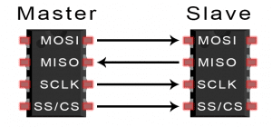
Here,
MOSI- It stands for Master Out and Slave In, that is master sends the data through this pin.
MISO- It stands for Master In and Slave Out, here the slave sends the data to the master.
SCLK- This is the clock line it helps in synchronising the data transfer between the master and the Slave, also in one cycle of a clock line one bit of data is transferred.
SS/CS- It is active low line and it is different line for each slave.

IF MULTIPLE SLAVES ARE USED THEN THE FOLLOWING TWO CIRCUITS CAN BE USED.

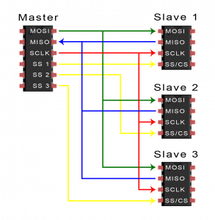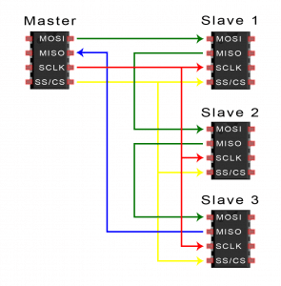
UART COMMUNICATION
Universal Asynchronous Receiver/Transmitter this mode of communications is relatively slow and uses two pins to communicate and at a time we can communicate only between two devices moreover unlike SPI and I2C it’s asynchronous that is it doesn’t uses any clock line. The pins that we use here are called Tx and Rx that is Transmitter and Receiver pins the Transmitter of one device is connected to the receiver of the other device and vice versa. Also they have a preset clock rate also known as Baud Rate measured in Bits per second and both the devices need to operate at the same baud rate. To start the data transfer the transmitter end pulls the high signals to low signals thus receiver ends starts reading the data from transmitter end.
In the data that is send by the Transmitter may include data of 5 or 8 bits of data sometimes it may upto 9 bits of data if parity signal is not included in it. A parity basically tells the odd or even number of 1’s in the data , if parity signal is 0 then it means that the signal contains even number of 1’s and the receiver verifies this data and checks if it has even number of ones thus making sure that data is received without errors also the same thing is done for the odd number of 1’s at this time the parity signal has value as 1. After the data is send the transmitter end sends the STOP signal which is converting the low signal to a high signal.

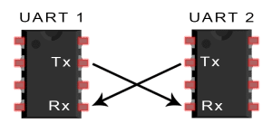
After receiving the data the receiver ends converts the data after removing start, stop and parity signal.

